**Day 3 - API Integration Report - [“FurniCraft”]**

**API Integration Process**

**1. Introduction**

On Day 3, the focus was on integrating the API into our system and ensuring that data from the API is displayed on the frontend and populated in the Sanity CMS. This document outlines the integration process, adjustments made to schemas, and the steps involved in data migration.

**2. API Integration Steps**

1. **Fetch Data from API:**
   * API Endpoint: https://template-0-beta.vercel.app/api/product
   * Used Axios to fetch product data from the API.
2. **Sanity Client Setup:**
   * Created a sanityClient.js file with the following configuration:
   * import { createClient } from '@sanity/client';
   * const client = createClient({
   * projectId: '', // Replace with your Sanity project ID
   * dataset: 'production', // Replace with your dataset name
   * useCdn: false,
   * token: '', // Replace with your Sanity API token
   * });
   * export default client;
3. **Inserting Data into Sanity:**
   * Created an API route /api/fetch-and-insert in the Next.js app:
   * import axios from 'axios';
   * import client from '../../sanityClient';
   * export default async function handler(req, res) {
   * try {
   * const { data } = await axios.get('https://template-0-beta.vercel.app/api/product');
   * for (const product of data) {
   * await client.create({
   * _type: 'product',
   * id: product.id,
   * name: product.name,
   * imagePath: product.imagePath,
   * price: parseFloat(product.price),
   * description: product.description,
   * discountPercentage: product.discountPercentage,
   * isFeaturedProduct: product.isFeaturedProduct,
   * stockLevel: product.stockLevel,
   * category: product.category,
   * });
   * }
   * res.status(200).json({ message: 'Data inserted successfully!' });
   * } catch (error) {
   * console.error(error);
   * res.status(500).json({ error: 'Failed to fetch or insert data' });
   * }
   * }
4. **Verifying Data in Sanity:**
   * Verified that the data is displayed correctly in Sanity CMS under the "Product" schema.

**Schema Adjustments**

**Updated Schema for Product**

* Added the following fields to the product schema:
* export default {
* name: 'product',
* title: 'Product',
* type: 'document',
* fields: [
* { name: 'id', title: 'ID', type: 'string' },
* { name: 'name', title: 'Name', type: 'string' },
* { name: 'imagePath', title: 'Image Path', type: 'url' },
* { name: 'price', title: 'Price', type: 'number' },
* { name: 'description', title: 'Description', type: 'text' },
* { name: 'discountPercentage', title: 'Discount Percentage', type: 'number' },
* { name: 'isFeaturedProduct', title: 'Is Featured Product', type: 'boolean' },
* { name: 'stockLevel', title: 'Stock Level', type: 'number' },
* { name: 'category', title: 'Category', type: 'string' },
* ],
* };
* Registered the schema and deployed it using the sanity deploy command.

**Migration Steps and Tools Used**

**1. Tools Used:**

* **Sanity.io**: For CMS management.
* **Axios**: To fetch API data.
* **Next.js**: For frontend development.

**2. Migration Steps:**

1. Fetched data from the provided API endpoint.
2. Parsed and validated data before inserting it into Sanity.
3. Created a dynamic UI in Next.js to display the fetched data.

**Screenshots**

1. **Data in Sanity CMS**

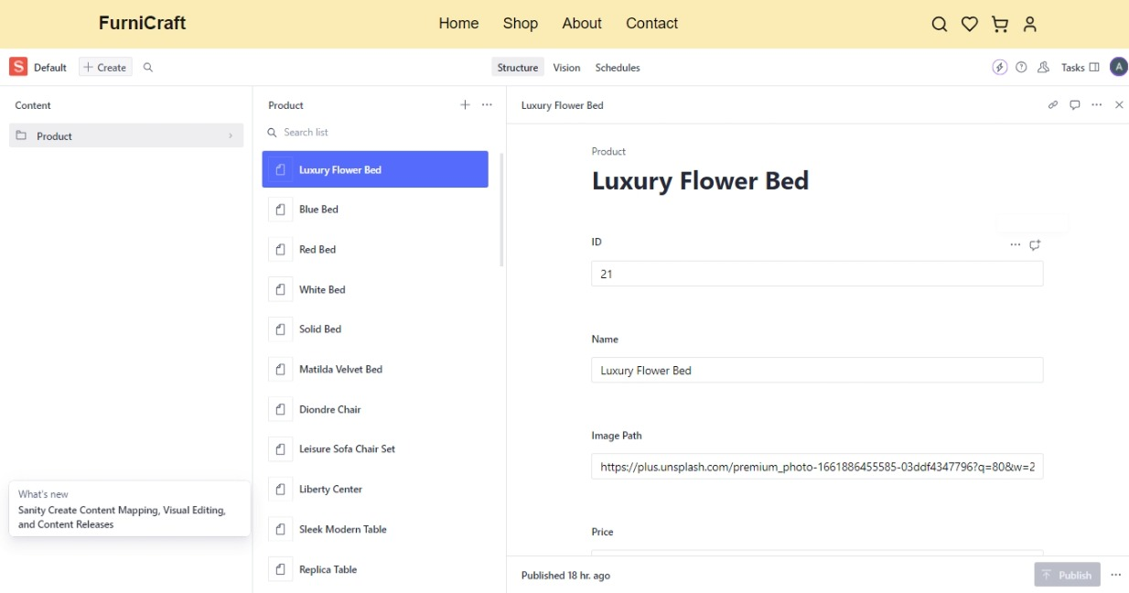

1. 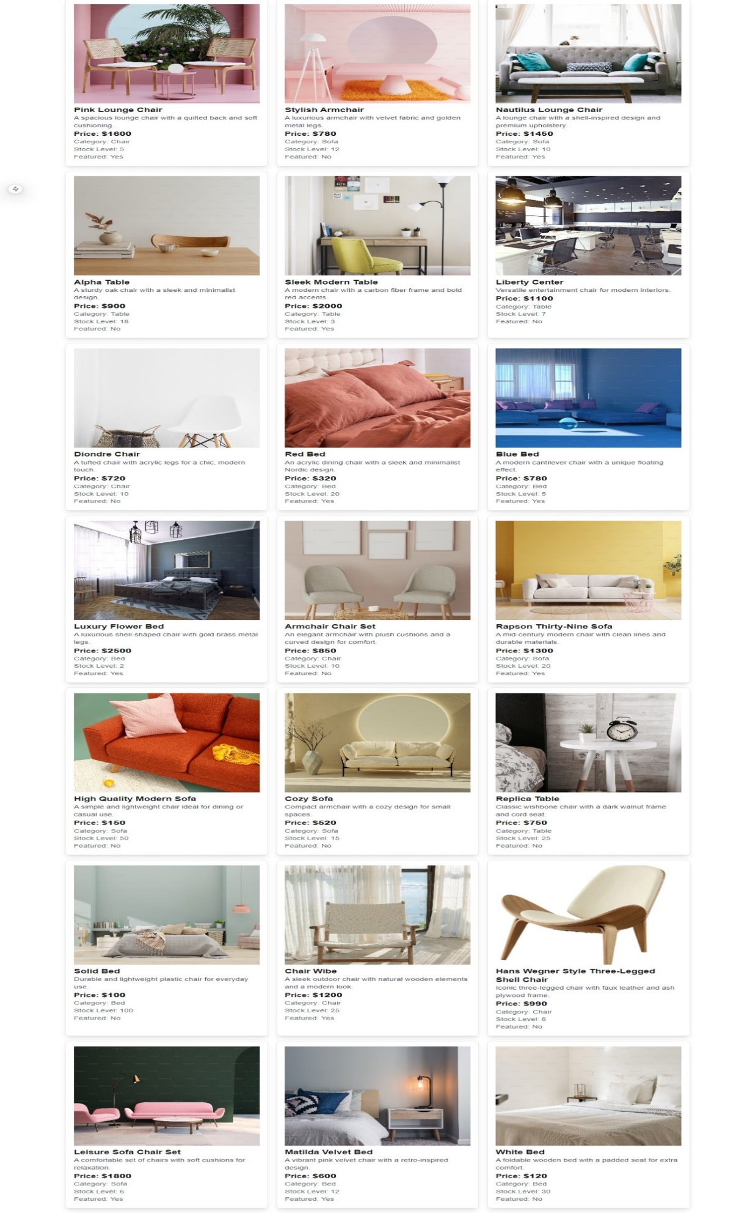

**Code Snippets**

**API Integration Code**

import axios from 'axios';

import client from '../../sanityClient';

export default async function handler(req, res) {

try {

const { data } = await axios.get('https://template-0-beta.vercel.app/api/product');

for (const product of data) {

await client.create({

_type: 'product',

id: product.id,

name: product.name,

imagePath: product.imagePath,

price: parseFloat(product.price),

description: product.description,

discountPercentage: product.discountPercentage,

isFeaturedProduct: product.isFeaturedProduct,

stockLevel: product.stockLevel,

category: product.category,

});

}

res.status(200).json({ message: 'Data inserted successfully!' });

} catch (error) {

console.error(error);

res.status(500).json({ error: 'Failed to fetch or insert data' });

}

}

**Frontend Code to Display Products**

import { client } from '@/sanity/lib/client';

async function fetchProducts() {

const products = await client.fetch(`*[_type == 'product'][0...21]`);

return products;

}

export default async function Home() {

const products = await fetchProducts();

return (

<div className="container mx-auto p-4">

<h1 className="text-3xl font-bold mb-4">Products</h1>

<div className="grid grid-cols-1 sm:grid-cols-2 lg:grid-cols-3 gap-4">

{products.map((product) => (

<div className="border rounded-lg p-4 shadow-lg" key={product._id}>

<img

className="w-full h-48 object-cover mb-2"

src={product.imagePath}

alt={product.name}

/>

<h2 className="text-xl font-semibold">{product.name}</h2>

<p className="text-gray-700">{product.description}</p>

<p className="text-lg font-bold">Price: ${product.price}</p>

<p className="text-gray-600">Category: {product.category}</p>

</div>

))}

</div>

</div>

);

}

**Conclusion**

The API integration was successfully completed, allowing data from the API to be displayed on the frontend and stored in Sanity CMS. Adjustments to the schema ensured all required fields were captured and displayed accurately.